Assignment 8
PNR: 260740150018
Name: PRATIK SUNIL ABHANG
Question:
Q1.
Write a Python program that accepts a sentence from the user and performs the following:
1. Count the number of vowels and consonants.
2. Count the number of digits and special characters.
3. Find the longest word in the sentence.
4. Display all words having more than 5 characters.
5. Check whether the sentence is a palindrome after removing spaces and converting it to lowercase.
Program
def analyze_sentence(text):
vowels = consonants = digits = special = 0
for ch in text:
if ch.isalpha():
if ch.lower() in "aeiou": vowels += 1
else: consonants += 1
elif ch.isdigit(): digits += 1
elif not ch.isspace(): special += 1
words = text.split()
longest = max(words, key=len) if words else ""
long_words = [word for word in words if len(word) > 5]
clean = "".join(text.lower().split())
return vowels, consonants, digits, special, longest, long_words, clean == clean[::-1]
def main():
default = "Madam 123! programming"
text = input(f"Enter a sentence: ").strip()
v, c, d, s, longest, long_words, palindrome = analyze_sentence(text)
print("Vowels:", v, "Consonants:", c)
print("Digits:", d, "Special characters:", s)
print("Longest word:", longest)
print("Words longer than 5:", long_words)
print("Palindrome:", palindrome)
main()

Input and Output
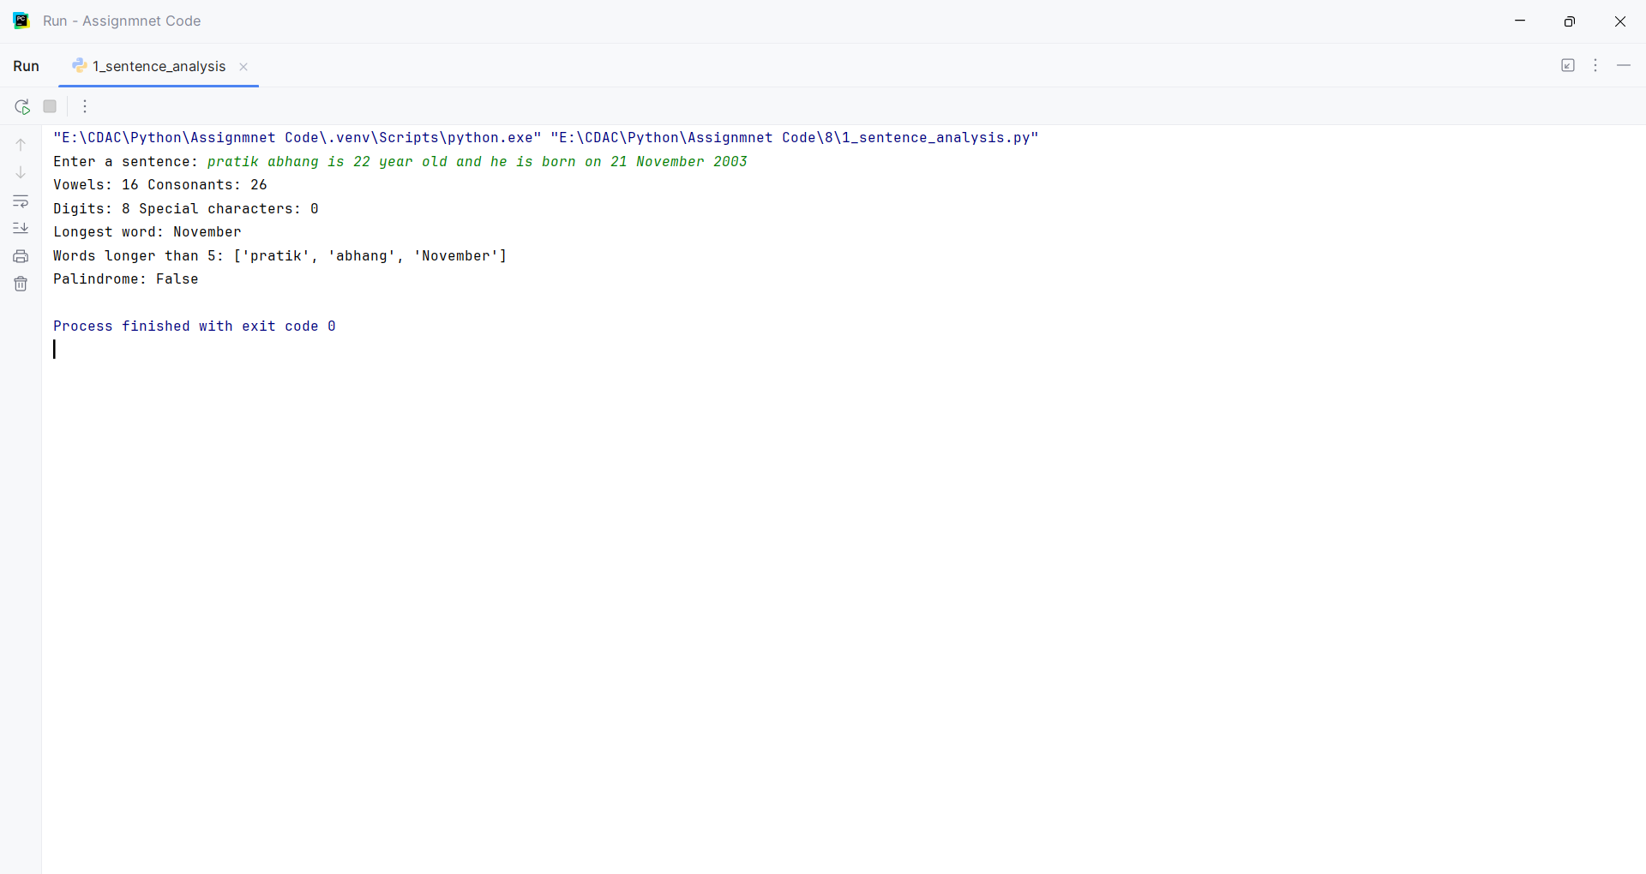
Question:
Q2.
Write a Python program to accept marks of n students into a list.
Perform the following operations:
1. Display all marks.
2. Find the highest and lowest marks without using max() or min().
3. Calculate the average marks.
4. Display students who scored above the average.
5. Count the number of students in each category:
o 75 and above – Distinction
o 60–74 – First Class
o 50–59 – Second Class
o Below 50 – Fail
6. Display the list in reverse order using a loop.
Program
def marks_report(marks):
high = low = marks[0]
for mark in marks:
if mark > high:
high = mark
if mark < low:
low = mark
average = sum(marks) / len(marks)
above = [mark for mark in marks if mark > average]
groups = {
"Distinction": 0,
"First Class": 0,
"Second Class": 0,
"Fail": 0
}
for mark in marks:
if mark >= 75:
groups["Distinction"] += 1
elif mark >= 60:
groups["First Class"] += 1
elif mark >= 50:
groups["Second Class"] += 1
else:
groups["Fail"] += 1
return high, low, average, above, groups
def main():
marks = [float(x) for x in input("Enter marks separated by spaces: ").split()]
high, low, average, above, groups = marks_report(marks)
print("All marks:", marks)
print("Highest:", high, "Lowest:", low, "Average:", round(average, 2))
print("Above average:", above)
print("Categories:", groups)
print("Reverse:", end=" ")
for i in range(len(marks) - 1, -1, -1):
print(marks[i], end=" ")
print()72
main()

Input and Output
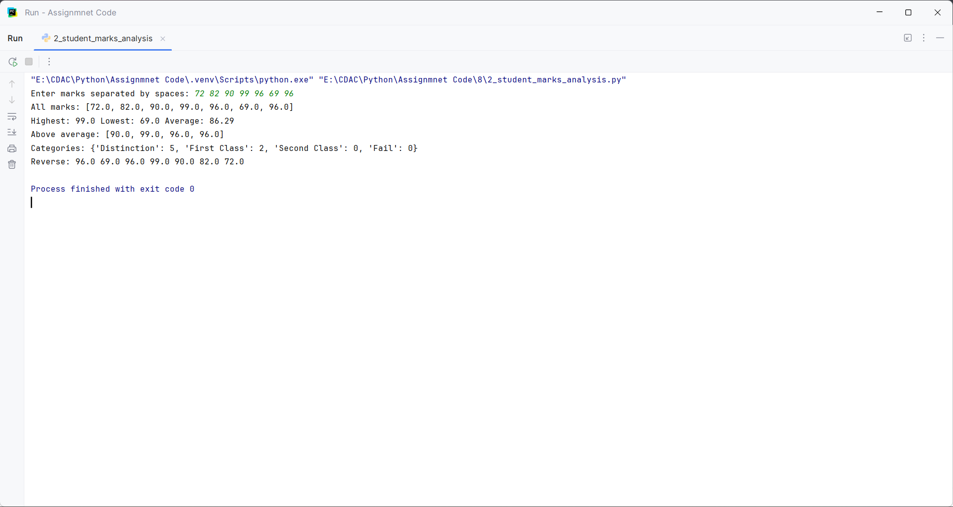
Question:
Q3.
Create a tuple containing employee records in the form:
(employee_id, employee_name, salary)
Write a program to:
1. Display all employees.
2. Find the employee receiving the highest salary.
3. Calculate the average salary.
4. Display employees whose salary is greater than the average.
5. Count employees based on salary categories:
o Below 30,000
o 30,000–60,000
o Above 60,000
6. Search for an employee by employee ID.
Program
def employee_report(employees):
print("All employees:")
for employee in employees:
print(employee)
highest = employees[0]
total = 0
for employee in employees:
total += employee[2]
if employee[2] > highest[2]:
highest = employee
average = total / len(employees)
print("Employee receiving highest salary:", highest)
print("Average salary:", average)
print("Employees whose salary is greater than average:")
for employee in employees:
if employee[2] > average:
print(employee)
below_30000 = 0
between_30000_60000 = 0
above_60000 = 0
for employee in employees:
if employee[2] < 30000:
below_30000 += 1
elif employee[2] <= 60000:
between_30000_60000 += 1
else:
above_60000 += 1
print("Below 30,000:", below_30000)
print("30,000 to 60,000:", between_30000_60000)
print("Above 60,000:", above_60000)
def search_employee(employees):
employee_id = int(input("Enter employee ID to search: "))
for employee in employees:
if employee[0] == employee_id:
print("Employee found:", employee)
return
print("Employee not found")
def main():
n = int(input("Enter number of employees: "))
employee_list = []
for i in range(n):
employee_id = int(input("Enter employee ID: "))
employee_name = input("Enter employee name: ")
salary = float(input("Enter salary: "))
employee_list.append((employee_id, employee_name, salary))
employees = tuple(employee_list)
employee_report(employees)
search_employee(employees)
main()

Input and Output
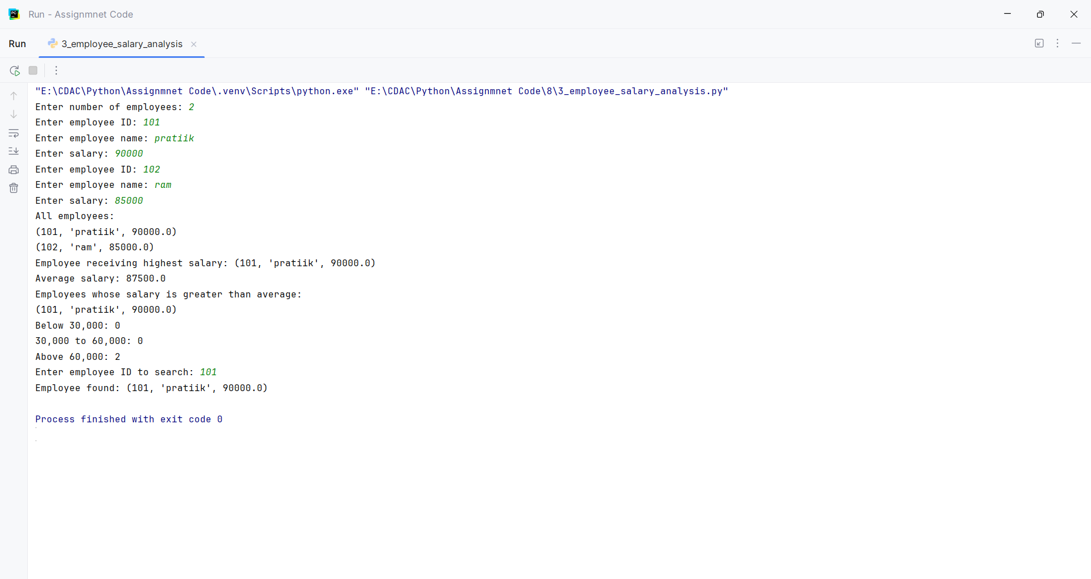
Question:
Q4.
Accept two lists of integers from the user and convert them into sets.
Write a program to:
1. Display unique elements from both lists.
2. Find the union.
3. Find the intersection.
4. Find elements present only in the first list.
5. Find elements present only in the second list.
6. Display common even numbers.
7. Display common odd numbers.
Program
def set_operations(first, second):
a = set(first)
b = set(second)
common = a & b
union = a | b
only_first = a - b
only_second = b - a
even = []
odd = []
for number in common:
if number % 2 == 0:
even.append(number)
else:
odd.append(number)
return a, b, union, common, only_first, only_second, even, odd
def main():
n1 = int(input("Enter number of elements in first list: "))
first = []
for i in range(n1):
number = int(input("Enter element: "))
first.append(number)
n2 = int(input("Enter number of elements in second list: "))
second = []
for i in range(n2):
number = int(input("Enter element: "))
second.append(number)
unique_first, unique_second, union, common, only_first, only_second, even, odd = set_operations(first, second)
print("Unique elements from first list:", unique_first)
print("Unique elements from second list:", unique_second)
print("Union:", union)
print("Intersection:", common)
print("Elements only in first list:", only_first)
print("Elements only in second list:", only_second)
print("Common even numbers:", even)
print("Common odd numbers:", odd)
main()

Input and Output
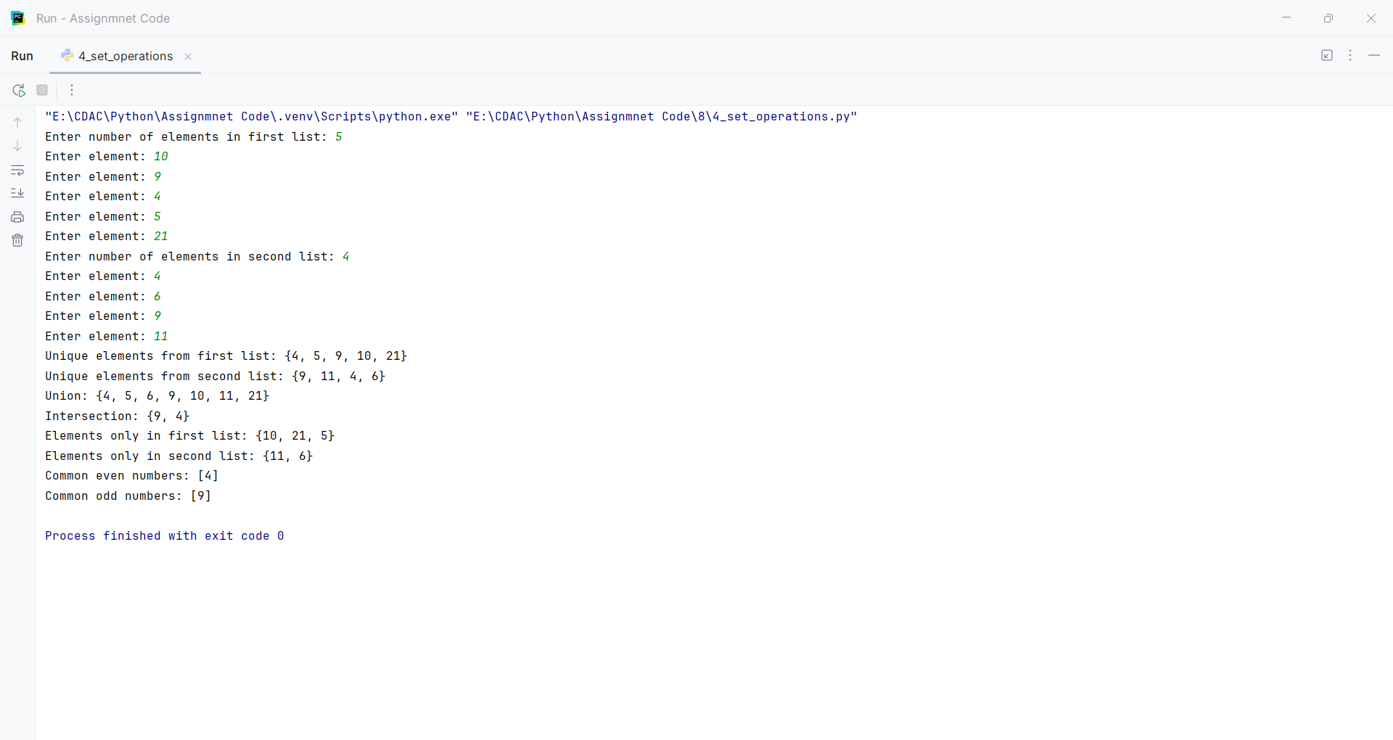
Question:
Q5.
Create a dictionary containing student names and their marks in three subjects.
Example:
students = {
"Amit": [75, 82, 68],
"Neha": [91, 88, 95],
"Rahul": [45, 52, 48]
}
Write a program to:
1. Calculate total and average marks for each student.
2. Assign grades using conditional statements.
3. Display students who have passed in all subjects.
4. Display the student with the highest average.
5. Count the number of students in each grade.
6. Search for a student by name.
Program
def grade(average):
if average >= 75: return "Distinction"
if average >= 60: return "First Class"
if average >= 50: return "Second Class"
return "Fail"

def student_report(students, name):
results, grade_count = {}, {}
best_name, best_average = "", -1
for student, marks in students.items():
total = sum(marks)
average = total / len(marks)
student_grade = grade(average)
results[student] = (total, average, student_grade, all(mark >= 50 for mark in marks))
grade_count[student_grade] = grade_count.get(student_grade, 0) + 1
if average > best_average: best_name, best_average = student, average
return results, grade_count, best_name, results.get(name)

def main():
students = {"Amit": [75, 82, 68], "Neha": [91, 88, 95], "Rahul": [45, 52, 48]}
name = input("Search student [Neha]: ").strip().title() or "Neha"
results, counts, best, found = student_report(students, name)
for student, data in results.items(): print(student, "Total:", data[0], "Average:", round(data[1], 2), "Grade:", data[2])
print("Passed all subjects:", [s for s, d in results.items() if d[3]])
print("Highest average:", best, "Grade counts:", counts)
print("Search result:", found or "Student not found")

main()

Input and Output
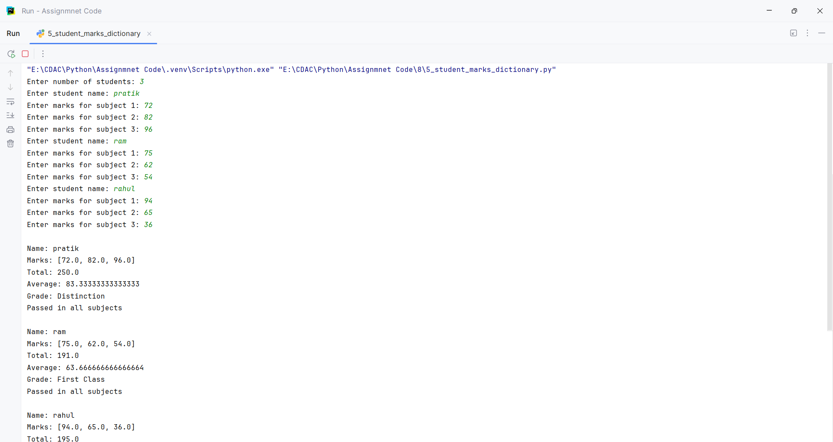
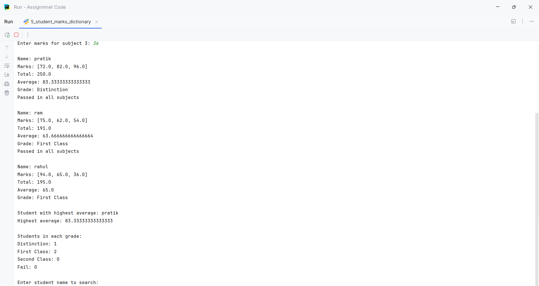
Question:
Q6.
Create a menu-driven Python program using user-defined functions.
The menu should contain:
1. Check Prime Number
2. Check Palindrome
3. Find Factorial
4. Generate Fibonacci Series
5. Exit
Create a separate function for each operation.
Program
def check_prime():
number = int(input("Enter a number: "))
if number < 2:
print("Not a Prime Number")
else:
for i in range(2, int(number ** 0.5) + 1):
if number % i == 0:
print("Not a Prime Number")
return
print("Prime Number")
def check_palindrome():
text = input("Enter a string: ")
if text == text[::-1]:
print("Palindrome")
else:
print("Not a Palindrome")
def find_factorial():
number = int(input("Enter a number: "))
if number < 0:
print("Factorial is not defined for negative numbers")
else:
factorial = 1
for i in range(1, number + 1):
factorial *= i
print("Factorial:", factorial)
def generate_fibonacci():
n = int(input("Enter number of terms: "))
first = 0
second = 1
print("Fibonacci Series:")
for i in range(n):
print(first, end=" ")
first, second = second, first + second
print()
def main():
while True:
print("\n1. Check Prime Number")
print("2. Check Palindrome")
print("3. Find Factorial")
print("4. Generate Fibonacci Series")
print("5. Exit")
choice = input("Enter your choice: ")
if choice == "1":
check_prime()
elif choice == "2":
check_palindrome()
elif choice == "3":
find_factorial()
elif choice == "4":
generate_fibonacci()
elif choice == "5":
print("Program Ended")
break
else:
print("Invalid Choice")
main()

Input and Output
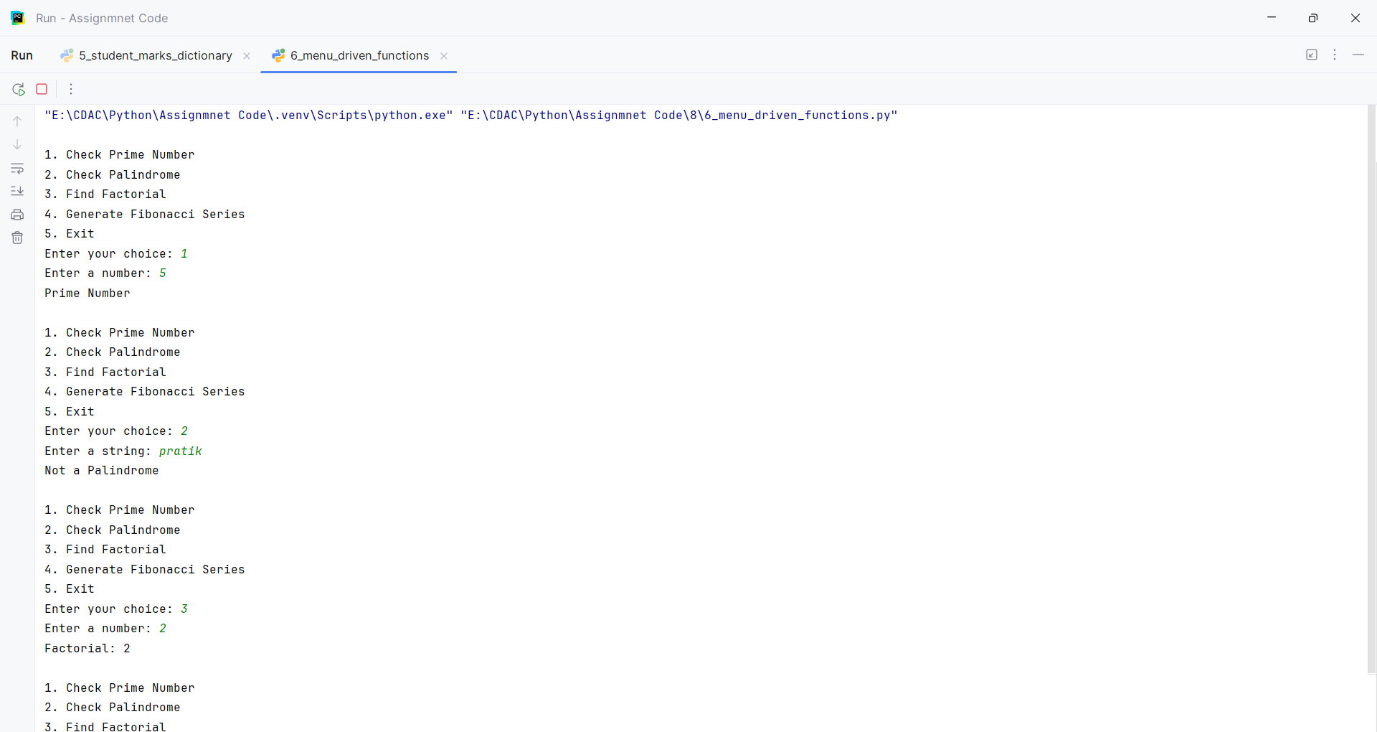
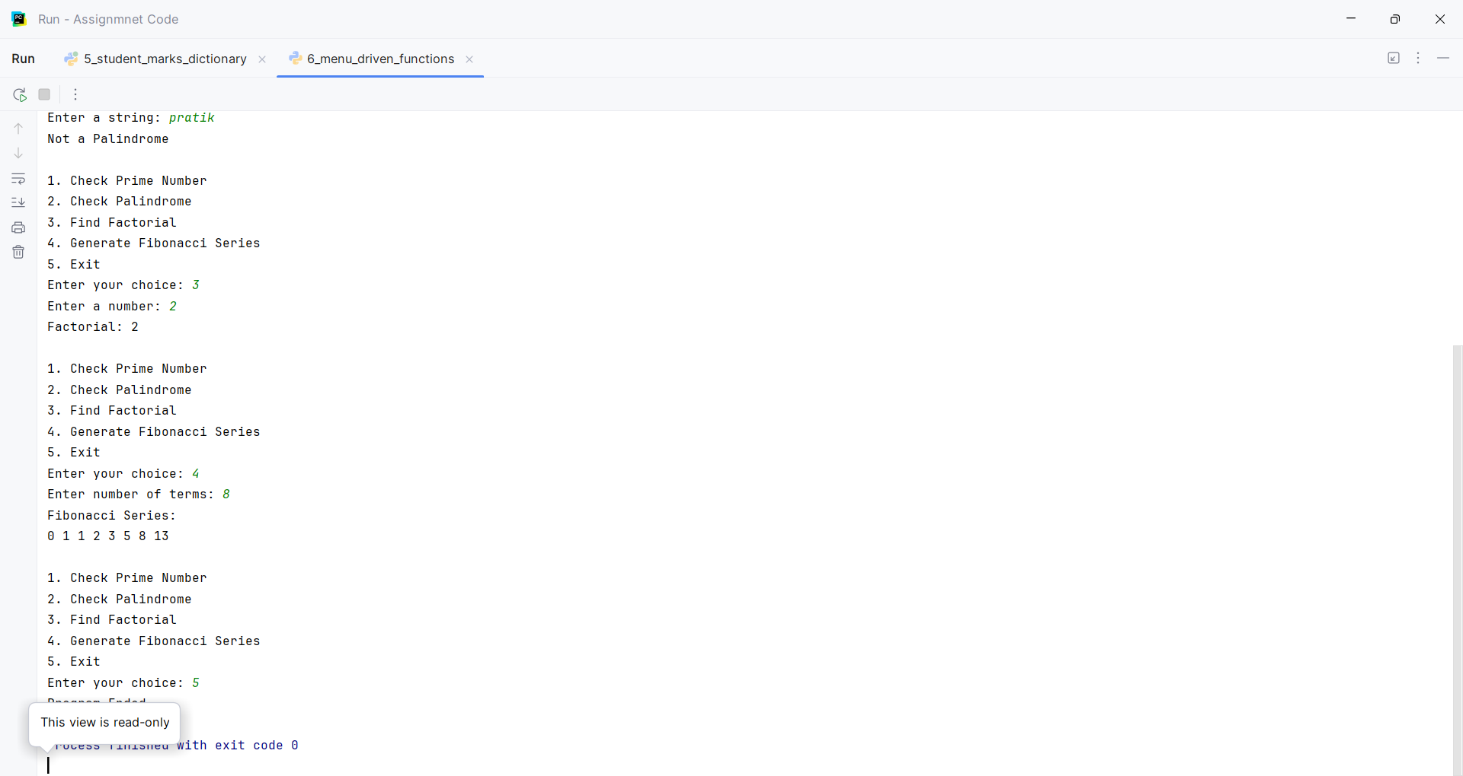
Question:
Q7.
Create a class BankAccount with the following attributes:
account_number
customer_name
balance
Create methods:
deposit()
withdraw()
check_balance()
display_details()
Apply the following conditions:
• Deposit amount must be greater than zero.
• Withdrawal amount must not exceed the balance.
• Display an appropriate message for insufficient balance.
• Allow multiple transactions using a loop.
• Provide a menu:
1. Deposit
2. Withdraw
3. Check Balance
4. Account Details
5. Exit
Program
class BankAccount:
def __init__(self, account_number, customer_name, balance):
self.account_number = account_number
self.customer_name = customer_name
self.balance = balance
def deposit(self):
amount = float(input("Enter deposit amount: "))
if amount > 0:
self.balance += amount
print("Deposit successful")
else:
print("Deposit amount must be greater than zero")
def withdraw(self):
amount = float(input("Enter withdrawal amount: "))
if amount <= 0:
print("Withdrawal amount must be greater than zero")
elif amount > self.balance:
print("Insufficient balance")
else:
self.balance -= amount
print("Withdrawal successful")
def check_balance(self):
print("Current balance:", self.balance)
def display_details(self):
print("Account Number:", self.account_number)
print("Customer Name:", self.customer_name)
print("Balance:", self.balance)
def main():
account_number = input("Enter account number: ")
customer_name = input("Enter customer name: ")
balance = float(input("Enter opening balance: "))
account = BankAccount(account_number, customer_name, balance)
while True:
print("\n1. Deposit")
print("2. Withdraw")
print("3. Check Balance")
print("4. Account Details")
print("5. Exit")
choice = input("Enter your choice: ")
if choice == "1":
account.deposit()
elif choice == "2":
account.withdraw()
elif choice == "3":
account.check_balance()
elif choice == "4":
account.display_details()
elif choice == "5":
print("Thank you")
break
else:
print("Invalid choice")
main()

Input and Output
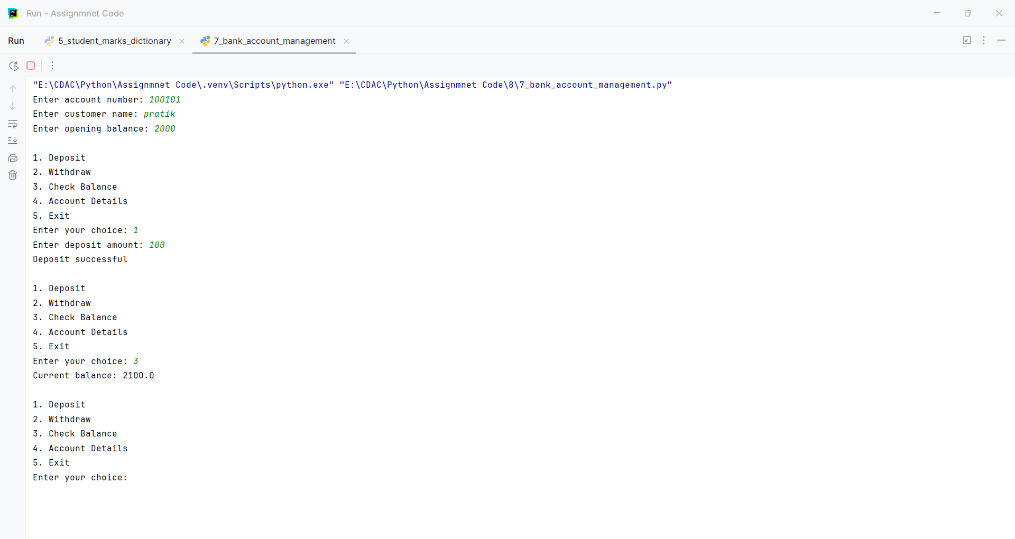
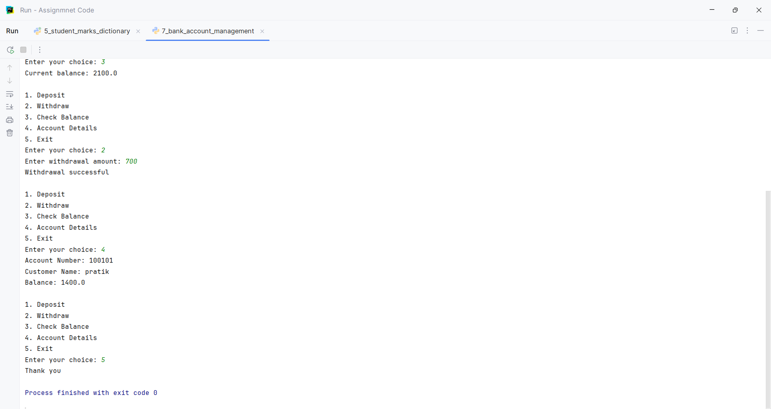
Question:
Q8.
Write a Python program using the re module to validate user input.
Validate:
1. Mobile number
2. Email address
3. Password
4. PIN code
5. Username
Use regular expressions and conditional statements to display whether each input is Valid or Invalid.
For the password, enforce:
• At least 8 characters
• At least one uppercase letter
• At least one lowercase letter
• At least one digit
• At least one special character
Program
import re
def validate_mobile(mobile):
pattern = r"^[6-9]\d{9}$"
if re.fullmatch(pattern, mobile):
return "Valid"
else:
return "Invalid"
def validate_email(email):
pattern = r"^[A-Za-z0-9._%+-]+@[A-Za-z0-9.-]+\.[A-Za-z]{2,}$"
if re.fullmatch(pattern, email):
return "Valid"
else:
return "Invalid"
def validate_password(password):
pattern = r"^(?=.*[A-Z])(?=.*[a-z])(?=.*\d)(?=.*[^A-Za-z0-9]).{8,}$"
if re.fullmatch(pattern, password):
return "Valid"
else:
return "Invalid"
def validate_pin(pin):
pattern = r"^\d{6}$"
if re.fullmatch(pattern, pin):
return "Valid"
else:
return "Invalid"
def validate_username(username):
pattern = r"^[A-Za-z][A-Za-z0-9_]{2,19}$"
if re.fullmatch(pattern, username):
return "Valid"
else:
return "Invalid"
def main():
mobile = input("Enter mobile number: ")
email = input("Enter email address: ")
password = input("Enter password: ")
pin = input("Enter PIN code: ")
username = input("Enter username: ")
print("Mobile number:", validate_mobile(mobile))
print("Email address:", validate_email(email))
print("Password:", validate_password(password))
print("PIN code:", validate_pin(pin))
print("Username:", validate_username(username))
main()

Input and Output
